AIM
To design and develop an online Hotel Room Booking System using HTML, CSS, and JavaScript to search room types, register users, and book rooms by selecting dates and guests.
Sample code
<!DOCTYPE html>
<html>
<head>
<title>Hotel Room Booking</title>
<style>
body {
font-family: Arial, sans-serif;
margin: 0;
background: #f5f1eb;
color: #333;
}

header {
background: #49352a;
color: white;
padding: 20px;
text-align: center;
}

nav {
background: #725440;
padding: 12px;
text-align: center;
}
nav a {
color: white;
margin: 15px;
text-decoration: none;
}
.container {
background: white;
width: 85%;
max-width: 600px;
margin: 20px auto;
padding: 20px;
border-radius: 10px;
box-shadow: 0 2px 8px #ccc;
}
input, select {
padding: 10px;
margin: 7px 0;
width: 90%;
box-sizing: border-box;
}
button {
padding: 10px 18px;
background: #725440;
color: white;
border: none;
cursor: pointer;
border-radius: 5px;
}
button:hover {
background: #49352a;
}
.room {
background: #f5f1eb;
padding: 12px;
margin: 10px 0;
border-radius: 5px;
}
.result {
color: green;
font-weight: bold;
}
</style>
</head>
<body>
<header>
<h1>Grand Stay Hotel</h1>
<p>Your comfort, our priority</p>
</header>
<nav>
<a href="#search">Search Rooms</a>
<a href="#login">Login</a>
<a href="#booking">Book Now</a>
</nav>

<div class="container" id="search">
<h2>1. Search Room Availability</h2>
<label>Check-in Date:</label><br>
<input type="date" id="checkin"><br>
<label>Check-out Date:</label><br>
<input type="date" id="checkout"><br>
<label>Number of Guests:</label><br>
<input type="number" id="guests" min="1" value="1"><br>
<button onclick="searchRooms()">Search Rooms</button>
<div id="searchResult"></div>
</div>
<div class="container" id="login">
<h2>2. User Registration / Login</h2>
<input type="text" id="username"
placeholder="Enter your name">
<input type="email" id="email"
placeholder="Enter your email">
<button onclick="login()">Register / Login</button>
<p class="result" id="loginResult"></p>
</div
<div class="container" id="booking">
<h2>3. Book a Room</h2>

<label>Select Room Type:</label><br>
<select id="roomType">
<option value="Standard">Standard - ₹1500/night</option>
<option value="Deluxe">Deluxe - ₹2500/night</option>
<option value="Suite">Suite - ₹4000/night</option>
<option value="Family">Family - ₹3500/night</option>
</select><br>

<label>Check-in:</label><br>
<input type="date" id="bookin"><br>

<label>Check-out:</label><br>
<input type="date" id="bookout"><br>

<label>Guests:</label><br>
<input type="number" id="bookGuests"
min="1" value="1"><br>

<button onclick="bookRoom()">Confirm Booking</button>

<p class="result" id="bookingResult"></p>
</div>

<div class="container">
<h2>Available Room Types</h2>

<div class="room">
<h3>Standard Room</h3>
<p>Comfortable room for a budget stay.</p>
<b>₹1500 per night</b>
</div>

<div class="room">
<h3>Deluxe Room</h3>
<p>Spacious room with premium facilities.</p>
<b>₹2500 per night</b>
</div>

<div class="room">
<h3>Suite Room</h3>
<p>Luxury room with extra space.</p>
<b>₹4000 per night</b>
</div>

<div class="room">
<h3>Family Room</h3>
<p>Suitable for families and groups.</p>
<b>₹3500 per night</b>
</div>
</div>

<div class="container">
<h2>Contact Us</h2>
<p>Email: grandstay@example.com</p>
<p>Phone: 9876543210</p>
<p>Check-in: 12:00 PM | Check-out: 11:00 AM</p>
</div>

<script>
let loggedIn = false;
let bookedRooms = [];

const prices = {
Standard: 1500,
Deluxe: 2500,
Suite: 4000,
Family: 3500
};

function validDates(start, end) {
return start && end &&
new Date(end) > new Date(start) &&
new Date(start) >= new Date(
new Date().toDateString()
);
}

function searchRooms() {
let start = document.getElementById("checkin").value;
let end = document.getElementById("checkout").value;
let guests = Number(document.getElementById("guests").value);

let result = document.getElementById("searchResult");

if (!validDates(start, end) || guests < 1) {
result.innerHTML =
"<p style='color:red'>Enter valid dates and guests.</p>";
return;
}

result.innerHTML = "<h3>Room Options</h3>";

for (let type in prices) {
result.innerHTML +=
"<p>" + type + " Room - ₹" +
prices[type] + " per night</p>";
}

result.innerHTML +=
"<p class='result'>Search completed successfully!</p>";
}

function login() {
let name = document.getElementById("username").value.trim();
let email = document.getElementById("email").value.trim();

if (!name || !email || !email.includes("@")) {
document.getElementById("loginResult").innerText =
"Enter a valid name and email.";
return;
}

loggedIn = true;

document.getElementById("loginResult").innerText =
"Welcome, " + name + "! You can now book a room.";
}

function bookRoom() {
let type = document.getElementById("roomType").value;
let start = document.getElementById("bookin").value;
let end = document.getElementById("bookout").value;
let guests = Number(document.getElementById("bookGuests").value);

let result = document.getElementById("bookingResult");

if (!loggedIn) {
result.innerText = "Please register or log in first.";
return;
}

if (!validDates(start, end) || guests < 1) {
result.innerText = "Enter valid dates and number of guests.";
return;
}

let nights = (new Date(end) - new Date(start)) /
(1000 * 60 * 60 * 24);

let total = nights * prices[type];

let booking = {
type: type,
start: start,
end: end,
guests: guests,
total: total
};

bookedRooms.push(booking);

result.innerHTML =
"Booking Successful!<br>" +
"Room: " + type + "<br>" +
"Check-in: " + start + "<br>" +
"Check-out: " + end + "<br>" +
"Guests: " + guests + "<br>" +
"Nights: " + nights + "<br>" +
"Total Price: ₹" + total;
}
</script>

</body>
</html>

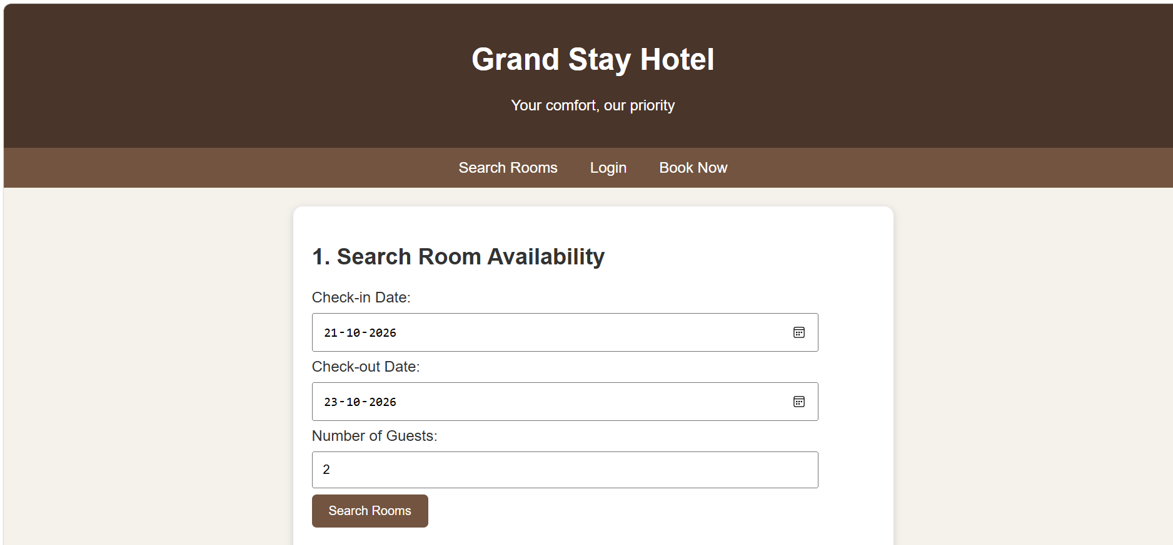

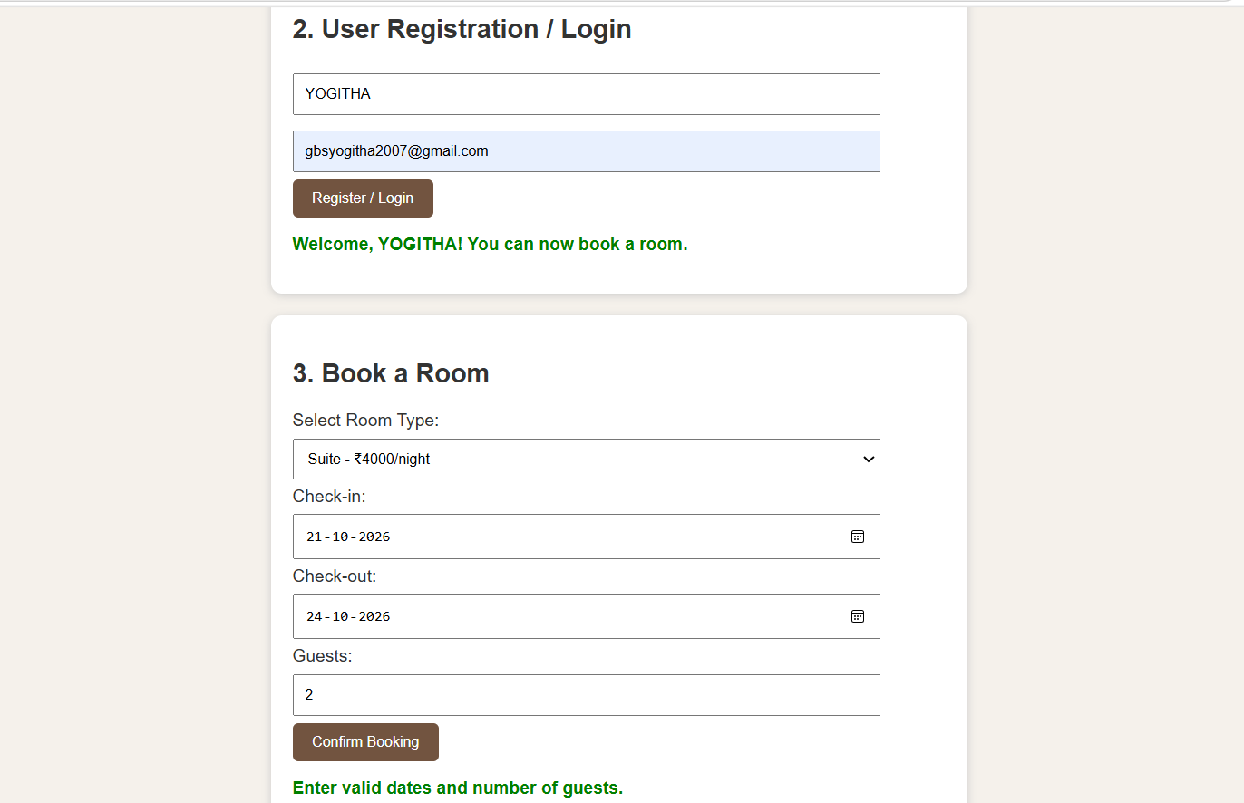

RESULT
Thus, the Hotel Room Booking website was developed successfully with three working functionalities: room search, user registration/login demonstration, and room booking with total price calculation.

